**UML DIAGRAM**

CLASS DIAGRAM

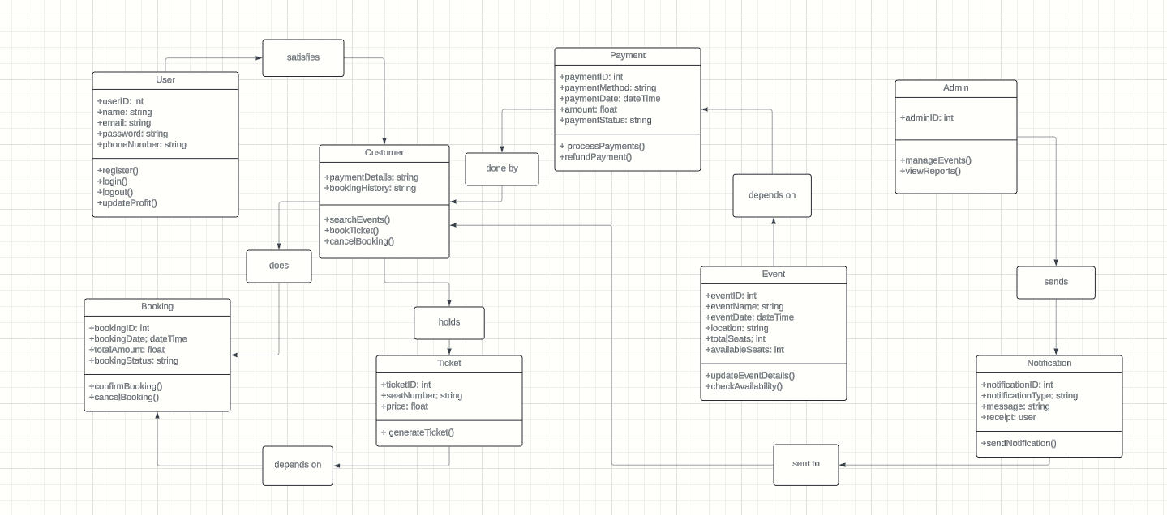

COMPONENT DIAGRAM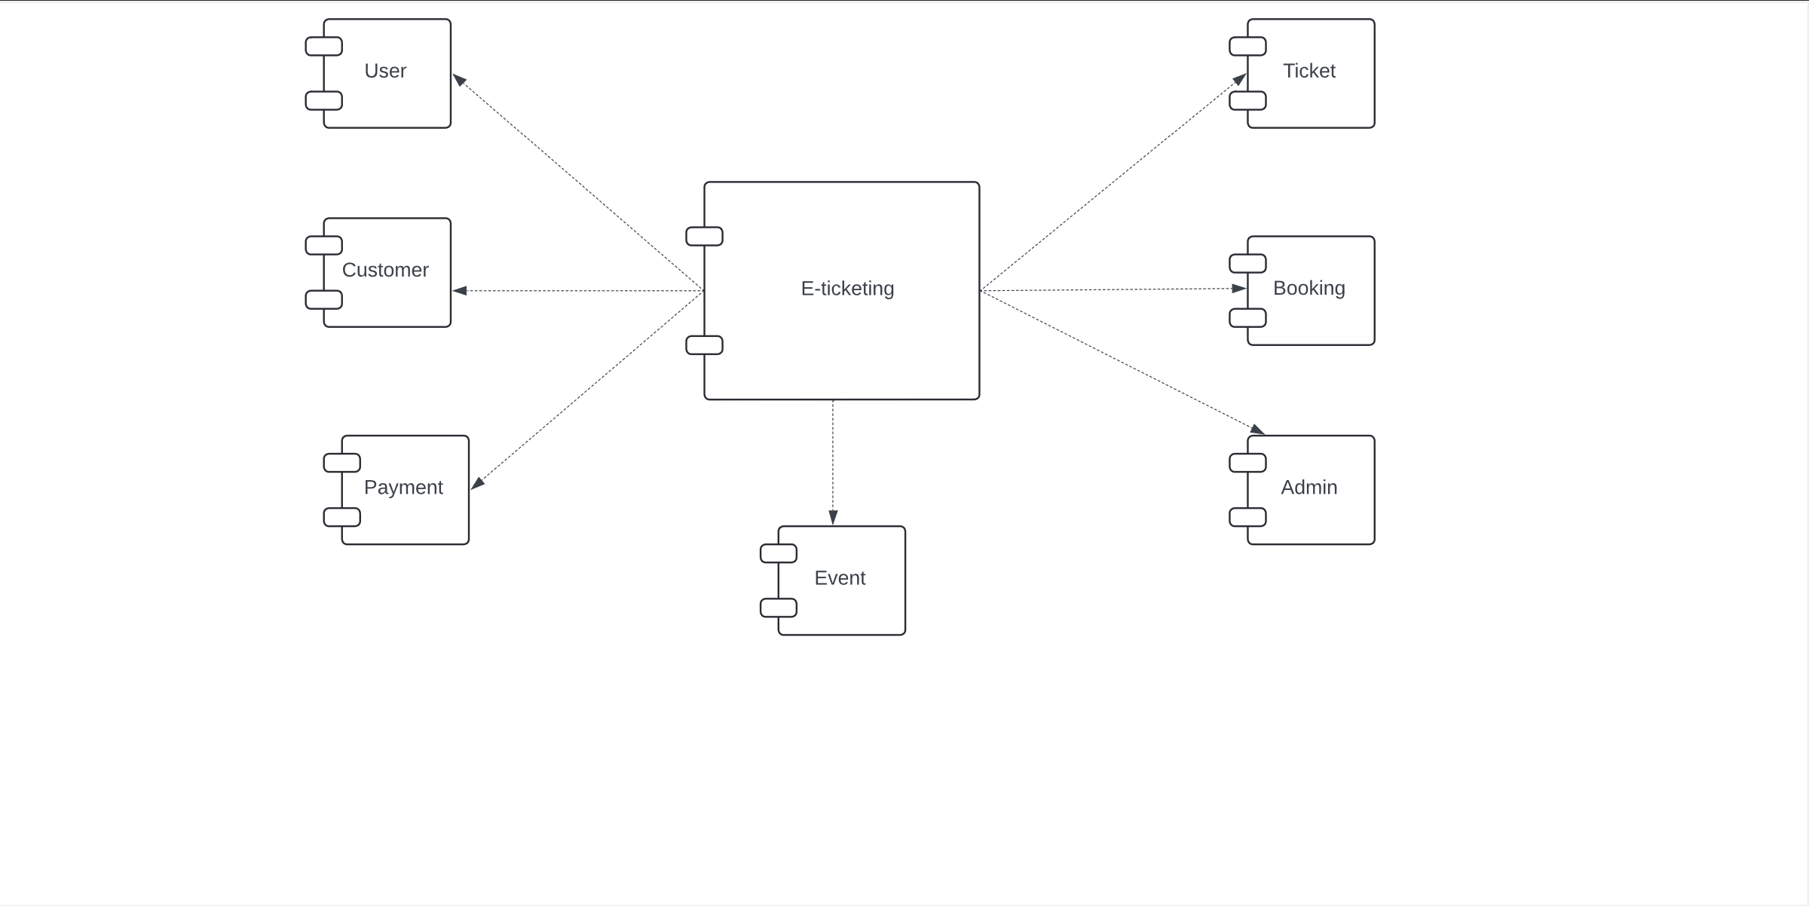

Use Case Diagram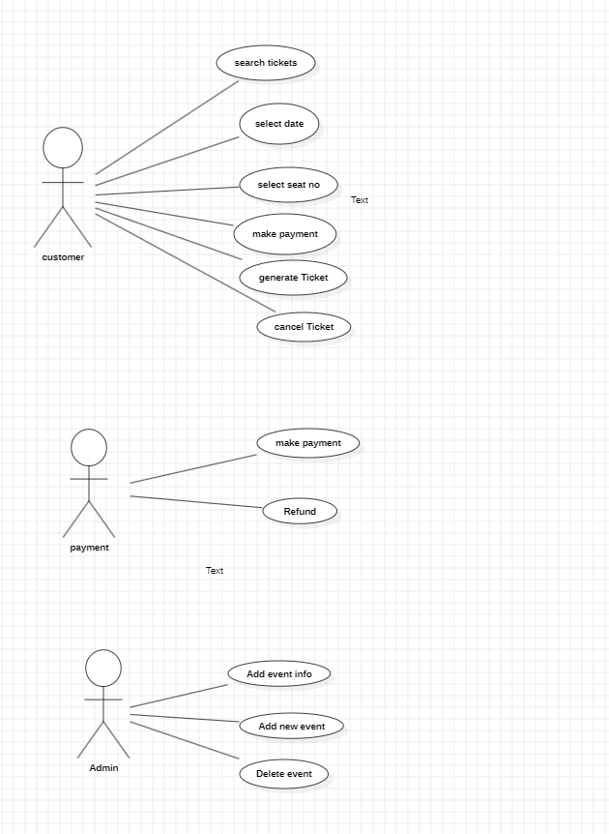

SEQUENCE DIAGRAM